Git Stages

Definition
# Source: AI Source: Provided by: [Data Path: Persons Table -> ID Column: 1, Name_En Column: Motasem Essam] -> From: [ChatGPT] on [2/19/2026]
Git Stages refers to the different areas or steps where your changes exist in Git before they are finally saved in the remote repository. It’s essentially how Git organizes your work before it becomes permanent. Think of it as a pipeline for your changes.

Git Stages Image
# Source: Table Source: Provided by: [Data Path: Persons Table -> ID Column: 1, Name_En Column: Motasem Essam] From: [Data Path: Miscellaneous Folder -> Miscellaneous Database -> Miscellaneous Table -> ID: 38] on [2/19/2026]
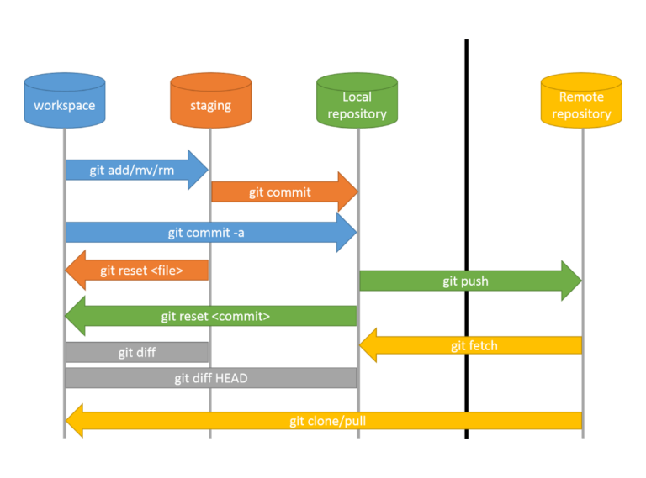

Stages in Git
# Source: AI Source: Provided by: [Data Path: Persons Table -> ID Column: 1, Name_En Column: Motasem Essam] -> From: [ChatGPT] on [2/19/2026]
There are four main stages in Git:

1️⃣ Workspace (or Working Directory)
# Source: AI Source: Provided by: [Data Path: Persons Table -> ID Column: 1, Name_En Column: Motasem Essam] -> From: [ChatGPT] on [2/19/2026]
- This is where you edit files on your computer.
- Any changes you make to files are first visible here.
- Example: You edit index.html or style.css.

2️⃣ Staging Area (or Index)
# Source: AI Source: Provided by: [Data Path: Persons Table -> ID Column: 1, Name_En Column: Motasem Essam] -> From: [ChatGPT] on [2/19/2026]
- After editing, you select which changes to include in the next commit.
- Command:
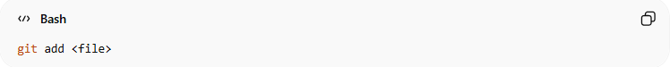
git add <file>
- Think of it like a waiting room: changes are ready to be saved, but not yet permanent.

3️⃣ Local Repository
# Source: AI Source: Provided by: [Data Path: Persons Table -> ID Column: 1, Name_En Column: Motasem Essam] -> From: [ChatGPT] on [2/19/2026]
- Once changes are staged, you commit them:
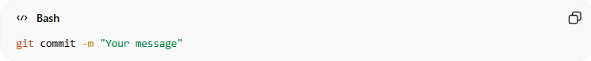
git commit -m "Your message"
- The changes are now saved in your local Git database.
- Only exists on your computer until you push them.

4️⃣ Remote Repository
# Source: AI Source: Provided by: [Data Path: Persons Table -> ID Column: 1, Name_En Column: Motasem Essam] -> From: [ChatGPT] on [2/19/2026]
- The final stage is pushing your commits to GitHub, GitLab, or any remote server:
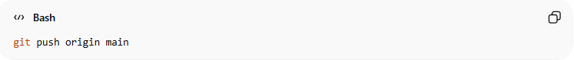
git push origin main
- This allows others to access your work.

💡 Quick Analogy:
# Source: AI Source: Provided by: [Data Path: Persons Table -> ID Column: 1, Name_En Column: Motasem Essam] -> From: [ChatGPT] on [2/19/2026]
- Workspace: your desk (where you work)
- Staging: a tray for finished documents waiting to be filed
- Local Repo: your personal filing cabinet
- Remote Repo: the company archive everyone can see

